ResREQUEST FOR COUNTRY ALLOCATION OF UNDP COVID-19 2.0

RAPID FINANCING FACILITY
Clearance

Criteria | Yes/No
Funding is provided to support the implementation of the UNDP COVID 2.0 offer in alignment with national priorities and needs, and in partnership with the UNCT and other partners. | YES
Proposal is aligned with priorities identified in national socio-economic impact assessments and/or national COVID-19 recovery plans. | YES
Proposal is complemented by other funds | YES
CO has expended at least 50 per cent of its RRF funding. | YES
Gender marker ratings (GEN2 or 3) validated. | GEN2

Technical Recommendation – Summary:

The proposal has gone through a comprehensive GPN/Hub technical review followed by a thorough quality assurance by the senior RBAS team and endorsement by the RBAS Regional Director a.i. for submission to the Investment Group. RBAS confirms that the proposal is fully compliant with RFF selection criteria and recommends the proposal from the CO in Libya for approval by the Investment Group.

Building upon the gains achieved via the activities funded under the Rapid Response Facility, the proposal aims at expanding them to cover areas that complement Libya’s ongoing COVID-19 response and recovery strategy. UNDP Libya intends to achieve this by strengthening psychosocial support to families and individuals, addressing the needs of households and small businesses in vulnerable communities for affordable and sustainable energy resources, and promoting digitization and e-governance.

In a context of mounting crises in Libya, implementing this proposal will ensure buy-in and potential future funding, such as the European Union and the Multi-donor Stabilization Trust Fund, to further expand the initiatives.

Substantive area of RFF REQUEST

- X Continued Health Crisis Support
- Governance
- Social protection
- X Green economy
- X Digital disruption and innovation

Proposal details (maximum APPROXIMATELY 3 pages)

Country: Libya
Requestor: Gozde Avci Legrand/ DRR
Project title (5-7 words) Kickstarting COVID-19 Recovery in Libya following a Green and Digital Pathway
Requested amount: 600.000 USD
Gender Marker: GEN 2
Date of submission: 23October 2020
Implementation Start Date: 1 December 2020
Implementation Complete Date: 30 April 2022

- Situation analysis

In Libya, the need to respond to the global health crisis only adds to the internal security, political and economic crises. People in Libya live in permanent uncertainty and fear, as the conflict continues.

The spread of COVID-19 in Libya has constituted the ‘fourth overlapping shock’ of the Libyan economy. Other shocks include an increasingly intensifying conflict that has suffocated the country’s economic activity; the closure of oil fields that has placed Libya’s major income-generating activity on hold; and falling oil prices that have reduced the income from oil production in the country’s surviving fields. These dynamics have created a socio-economic matrix of various challenges for the country’s communities, especially those that are in remote parts of the country. Libya’s economic recession has spiraled into an ever-worsening currency and liquidity crisis, with the Libyan dinar losing most of its value. The prices for basic commodities have skyrocketed making basic goods no longer affordable nor accessible to large parts of the population – including refugees and migrants. The conflict has also led to a lack of structural energy planning and scheduled maintenance, outdated transmission infrastructure and poor management, resulting in a deteriorating energy services situation, making the need to have sustainable electricity sources at the household level pressing.

The WHO puts Libya among the high-risk countries in the region. With limited access to healthcare in areas affected by the on-going conflict, the current limited testing capacity (there are only two testing laboratories in Tripoli and Benghazi), limited contact tracing, hard to reach populations and increasing social stigmatization discouraging people to seek help when they fall sick, particularly with mental health related issues. There is a genuine fear that the number of positive cases could be far higher than what is being reported. Following weeks of intensified armed clashes in April-May 2020 that affected a solid COVID-19 response by the government, cases in Libya grew exponentially; while a change in conflict dynamics caused the displacement of approximately 24,000 people from their homes – putting the lives of vulnerable populations (i.e., women, migrants, youths and people with disabilities) at risk. In spite of limited testing capacities, Libya recorded by mid-September more than 25,000 confirmed COVID-19 cases and over 400 confirmed COVID-19 related deaths.

Compounding this scenario is the decreasing humanitarian space due to COVID-19 related travel and security restrictions. Despite several diplomatic overtures and meetings since the start of 2020 and calls for a cessation in the armed conflict on humanitarian grounds in order to respond to COVID-19, the conflict in Libya simmers on and risks to flare up again.

The impact of COVID-19 has required a period of discreet bilateral engagement by UNSMIL and key National and regional interlocutors. There was a successful resumption of the intra-Libyan dialogue on 17 September 2020 when UNSMIL/UNDP virtually convened the third meeting of the Libyan Economic Dialogue. Discussions focused on economic development and a review of the policy roadmap developed as part of the Berlin peace process. In the event of a peace agreement the impact of UNDP’s COVID-19 remedial efforts would be further strengthened within a stable political and security environment, which will benefit the Libyan people (especially the most vulnerable).

- Proposal overview and expected outputs

UNDP aims to build upon the gains achieved via the catalytic activities funded under the Rapid Response Facility (RRF) while expanding them to cover areas that complement the ongoing COVID-19 response and recovery strategy.

Output 1: Continued health crisis support

The Libyan population has been affected by almost 10 years of multiple crises, which have reduced the resilience of the population. COVID-19 now puts extra stress on people’s health care, family situation, employment and income. Mental health-related perceptions and practices in Libya are not fully recognized or appreciated in the society, and existing capacity of psychosocial support is poor.

Victims of COVID-19 could feel additionally stigmatized, especially those already suffering from mental health and psychosocial disorders. It is essential that the appropriate mental health support is provided to increase their coping mechanisms. In this light, the proposal envisages light rehabilitation of a medical center enabling mental health services in a city affected by war and COVID 19, which will enhance psychological support to families and individuals.

Output 2: Green economy promoted through the provision of affordable and sustainable energy resources to households and small businesses

To address the need to develop sustainable electricity sources at the household/ small business level, this proposal seeks to explore Libya’s massive unexplored potential for solar energy by setting up a renewable energy pilot project focusing specifically on addressing the needs of households and small businesses in vulnerable communities. The intention is to provide them with affordable and sustainable energy resources. In terms of empowering women, and facilitating their inclusion in the management of the production and distribution of solar energy, the project aims to engage women in a managerial capacity so that they are empowered socially, professionally and economically while making decisions on what is important for the local community.

If suitably harnessed, solar energy has the potential to meet the future energy needs of an increasing number of Libyans. Due to its inexhaustible supply and non-polluting character, solar energy is expected to become increasingly attractive as a renewable source of energy in Libya.

Output 3: Financing supported through the promotion of digitalization and e-governance

To respond to the aforementioned currency and liquidity crisis, and in order to stabilize the prices of basic commodities this project plans on tapping into Libya’s immense resources (i.e., its highly skilled and educated work force) and expanding digital infrastructure. UNDP Libya aims to focus on ways digitalization can support and create different financing options that meets the priorities of the people intended to be served. This will empower them as savers, lenders, borrowers, investors, and taxpayers. UNDP Libya plans to assess and undertake a pilot project working with the already existing e-payment platforms. The aim would be to catalyze ways in which these platforms can help the most vulnerable, i.e. women, youths and internally displaced populations, to access digital finance services and overcome barriers in cash payments by exploring opportunities to harness digital payment platforms. In addition, UNDP Libya is about to start Cash for Work (CfW) activities in Libya. Such e-payment platforms will help UNDP Libya expand its CfW activities to all parts of Libya.

It should be noted that the proposed activities to be funded under RFF are intended to build upon ongoing COVID-19 interventions to alleviate the socio-economic impact of the pandemic focusing on strengthening health-care systems and generating income for the vulnerable populations. RFF funding will build on interventions undertaken through;

- RRF project regarding digital innovation building on the Telemedicine initiative,
- Stabilization Facility for Libya (SFL) in terms of replicating the psycho-social support model previously developed.
- Strengthening Local Capacities and Resilience in Libya Project (SLCRR) in terms of providing livelihoods opportunities through green economy.
- Japanese Supplementary Budget (JSB)/START project regarding digital e-payments in Cash-for-Work activities.

In parallel, RFF activities will also form part of the initial steps towards a comprehensive socio-economic response to the impact of COVID-19 in Libya. These areas directly correlate with two of the five Pillars that make up the recently concluded UN Socio-Economic Framework for the Response to COVID-19 in Libya (UNSEF) i.e. Output 1/ Pillar I: Health First + Pillar III Economic Response and Recovery. In addition to this, UNDP Libya has opted to use (technological) innovation as a means to spearhead solutions to the negative impact of COVID-19 in the health and economic sectors. With a young and highly literate population, Libya is well positioned to harness the benefits of new and emerging technologies as a means for effective solutions during this pandemic.

- Management arrangements

The project will be implemented through a direct implementation modality (DIM), with UNDP Libya working closely with the UNCT within the Multi-Sector Response led by the RC, and in close coordination with Government and other partners. UNDP will leverage existing operational projects/presences/coordination mechanisms established under its Resilience and Stabilization projects to support Municipalities and recovery across the country.

The initiative is connected to the overall Government and UN response. The RFF proposal is within the strategic response of UNDP Libya to COVID-19 2.0. As an active member of the UNCT, HCT and Health Cluster and the lead for Livelihoods Working Group, UNDP has ensured consultation with WHO, the RC/HC and UN Health Cluster and Humanitarian Coordination Mechanism, who are supportive of UNDP’s positioning and strategy. The Ministries of Health and Planning are also fully supportive.

In addition to the proposed RFF allocation, UNDP Libya will be re-allocating funding from two of its largest existing programmes- Stabilization Facility for Libya (SFL) and Strengthening Local Capacities and Resilience in Libya Project (SLCRR) - with the permission of the Government and donors to support implementation.

Implementation of the RFF proposal will be overseen by the RR with the DRR leading the project, with the overall support of the Development Coordinator (Project Specialist), and support in implementation of Project Managers and teams of the SFL and SLCRR projects as well as the CO Communications Officer in the support role. Subsequently, the implementation does not require DPC.

- Partnerships

UNDP Libya will work closely with the UNCT within the Multi-Sector Response led by the DSRSG/RC/HC, and in close coordination with Government, local authorities, private sector and other partners such as NGOs. Specific partnerships per output are:

- Output 1 on psycho-social support: in addition to local authorities, UNDP Libya will engage with non-governmental organizations as well as the members of the Protection Working Group led by UNFPA. UNDP will continue its partnership with WHO and UNFPA to create a catalytic effect.
- Output 2 on green energy: in addition to the local authorities, UNDP Libya will work with local community groups as well as local private sector companies. As the leading agency for the Libya Livelihoods Working Group, UNDP will collaborate with all members during the implementation period.
- Output 3 on digitalization: UNDP will work closely with the Ministry of Health and the private sector (a Libyan start-up, Speetar, with which UNDP Libya is partnering for Telemedicine) as well as WHO.

- Complementarity with other funds available for COVID-19

The RFF is complementary with other funds UNDP Libya received for COVID-19, such as the Rapid Response Facility (RRF), Japanese Supplementary Budget (JSB) for COVID-19 and existing projects that also include a COVID-19 response focus, such as Stabilization Facility for Libya (SFL), Strengthening Local Capacities and Resilience in Libya (SLCRR) and Stabilization to Recovery Transition (START) project.

Financial partner | Project title | Pipeline | Tentative budget (USD)
Multi-donor Trust Fund (Germany, EU, UK, France, Korea, Italy, Netherlands, Norway) | Stabilization Facility for Libya (SFL) | A | 400,000 USD
EU | Strengthening Local Capacities and Resilience in Libya (SLCRR) | A | 200,000 USD
Japanese Supplementary Budget (JSB) | Stabilization Facility for Libya (SFL) | A | 2,000,000 USD
Korea | Inclusive business – vocational training center | A | 500,000 USD
Total |  |  | 3,100,000 USD

Activities funded under the RFF such as telemedicine, e-payment platforms, the rehabilitation of hospitals to provide psycho social care and the provision of renewable energy for households and small businesses have a catalytic effect that the CO is planning to scale up via other donors’ funds, such as the Japanese Government, the European Union and the Multi-donor Stabilization Trust Fund. Green economy and digital finance activities are catalytic livelihoods activities for the SLCRR project (small business and household livelihoods support funded by EU) and the Japanese Supplementary Budget /START project (e-payments for Cash For Work funded by the Japanese Government) that will be initiated next year. Continued health support proposed under the RFF will allow UNDP to scale up successful pilot project undertaken in the crisis-stricken areas with SFL project (Multi-Donor funding). The innovative telemedicine activity which has been initiated under the RRF in partnership with the private sector and the Ministry of Health will be strategically scaled up throughout Libya under the RFF.

UNDP Libya is planning to further involve partners and potential donors from the beginning to ensure buy-in and potential future funding to further expand these activities.

UNDP Libya is planning to further involve partners and potential donors from the beginning to ensure buy-in and potential future funding to further expand these activities such as establishing a business framework for the SDGs and 2030 Agenda in a way that is accessible to the private sector. In addition, private sector actors will be helped to navigate and enhance their presence in the development environment by introducing inclusive business models, and SDG impact management training and support for Libyan companies.

- Risk mitigation

- Safety and security: A deteriorating impasse of the political conflict, resumed armed clashes and/or a renewed militarily escalation in the targeted area could affect the implementation of the project.
  - Impact: 3-4/5
  - Likelihood: 1-2/5
Risk mitigation: close assessment of the security situation; deployment of project coordinator to coordinate with different parties.

- Political: Lack of buy-in from local authorities would undermine effective implementation
  - Impact: 4/5
  - Likelihood: 1-2/5
Risk mitigation: Close liaison and ongoing engagement with local authorities and community groups to ensure government buy-in.

- Social risk: Lack of inclusive participation
  - Impact: 3/5
  - Likelihood: 3/5
Risk mitigation: Close liaison and ongoing engagement with community groups to ensure inclusive participation and ownership.

- Strategic: Lack of coordination and integration with other initiatives that envisage the same overall objective could result in a stand-alone project without a catalytic impact
  - Impact: 4-5/5
  - Likelihood: 2-3/5
Risk mitigation: Embedding RFF project in UNDP Libya’s wider support to the targeted local communities; e.g. SFL, Resilience, CSI, START to make sure that when the specific activity is delivered, sustainability and catalyst impact is supported.

BUDGET / WORKPLAN

EXPECTED OUTPUTS | PLANNED ACTIVITIES  List all activities including M&E to be undertaken during the year towards stated CP outputs | TIMEFRAME |  |  |  |  |  | RESPONSIBLE PARTY | PLANNED BUDGET
 |  | 2020 | 2021 |  |  |  | 2022 |  | Source of Funds | Budget Description | Amount
 |  | Q4 | Q1 | Q2 | Q3 | Q4 | Q1
Output 1. Continued Health Crisis Support | 1.1 Consultations with partners and local communities, including women’s groups to identify the most appropriate community for the rehabilitation of a mental health center | x | x | x | x | x |  | UNDP | RFF | Consultations (site visits) | 5,000
 | 1.2 Planning, procurement and implementation of the rehabilitation works |  | x | x | x | x |  | UNDP | RFF | Technical expertise, Purchase of material, equipment; Refurbishing works | 130,000
 | 1.3 Training for psychosocial support |  |  |  | x | x | x | UNDP | RFF | Trainings (incl. training material) | 10,000
Subtotal Output 1 |  |  |  |  |  |  |  |  |  |  | 145,000
Output 2. Green economy promoted through the provision of affordable and sustainable energy resources to households and small businesses | 2.1 Conduct feasibility study including a gender analysis | x | x |  |  |  |  | UNDP | RFF | Consultation; | 5,000
 | 2.2 Procurement of power supplying appliances for household and small business level usage |  | x | x | x |  |  | UNDP | RFF | Purchase of material and equipment;  Project assistant; | 70,000
 | 2.3. Identification of local women’s cooperatives and community organisations and training on operation and maintenance of the renewable energy equipment. |  |  | x | x | x |  | UNDP | RRF | Consultation and training | 5,000
 | 2.4 Effectiveness and efficiency assessment (3-6 months after delivery) |  |  |  |  |  | x | UNDP | RFF | Survey | (included in 2.3 budget)
 | 2.5 Coordination expertise |  | x | x | x | x |  | UNDP | RFF | Coordinator | 50,000
Subtotal Output 2 |  |  |  |  |  |  |  |  |  |  | 130,000
Output 3. Financing supported through the promotion of digitalization and e-governance | - Assessment of digital finance (e-payments) sector in Libya with a focus on gender-disaggregated data | x | x |  |  |  |  | UNDP | RFF | Consultations | 5,000
 | - Supporting digital based pay platforms for development of applications |  | x | x |  |  |  | UNDP | RFF | ICT experts | 40,000
 | - Awareness campaign aimed at women, IDPs, migrants to increase the usage of digital based pay platforms |  | x | x | x |  |  | UNDP | RFF | Awareness expertise | 5,000
 | - Telemedicine activities, coordination between hospitals and patients |  | x | x | x | x |  | UNDP | RFF | Software development, consultations, awareness | 100,000
 | - Further development of telemedicine application,  provision of feature related to reproductive health and survivors of GBV/ SGBV |  | x | x | x | x |  | UNDP | RFF | Software development, consultations, awareness | 70,000
 | 3.6 Awareness raising/communications regarding the usage of telemedicine |  | x | x | x |  |  | UNDP | RFF | Awareness, training (incl. training material) | 5,000
 | - Telemedicine services in remote areas |  |  | x | x | x |  | UNDP | RFF | Consultation coordination | 50,000
 | - Technical support and expertise |  | x | x | x | x |  | UNDP | RFF | ICT experts | 50,000
Output 3 |  |  |  |  |  |  |  |  |  |  | 325,000
GRAND TOTAL |  |  |  |  |  |  |  |  |  |  | 600,000

RESULTS FRAMEWORK
EXPECTED OUTPUTS | OUTPUT INDICATORS | BASELINE |  | MILESTONES AND TARGETS |  |  |  |  |  | (aggregated)
 |  | Value | Year | 2020 |  | 2021 (aggregated) |  |  |  | 2022
 |  |  |  | Q3 | Q4 | Q1 | Q2 | Q3 | Q4 | Q1
Output 1. Continued Health Crisis Support | Minimum of 2 health facilities rehabilitated | 1 | 2019 | -  - | - | - | - | 1 | 1 | 2
 | Minimum of 16 health care workers hired or trained for post- COVID-19 (mental health) response, disaggregated by sex (at least 30% women) | 0 | NA | - | - | - | - | 4 | 12 | 16
Output 2. Green economy promoted through the provision of affordable and sustainable energy resources to households and small businesses | Minimum of 5 households that receive green energy / green economy support, related to COVID-19 (disaggregated data) | NA | NA | - | 0 | 0 | 0 | 3 | 2 | 5
 | Minimum of 6 small businesses that receive green energy / green economy support, related to COVID-19 (disaggregated data, 50% women) |  |  | - |  |  |  | 3 | 3 | 3 men-led businesses  3-women-led businesses
Output 3. Financing supported through the promotion of digitalization and e-governance | One assessment on the digital finance sector | 0 | 2020 | - | 0 | 0 | 0 | 1 | 1 | 1
 | One digital solution created to address the COVID-19 pandemic. | 0 | 2020 | - | 0 | 0 | 0 | 0 | 1 | 1
 | Minimum of 10 women businesses outreached by awareness campaigns to advocate digital solutions | NA |  |  |  |  |  | 5 | 5 | 10
 | Minimum of 3 hospitals / health centers linked to the application | NA |  |  |  |  | - | 1 | 2 | 3 in total (1 in the west, 2 in the east and 1 in the south)

Annex: Green Economy / Green Energy
Potential different solar applications include

- Solar cooking system

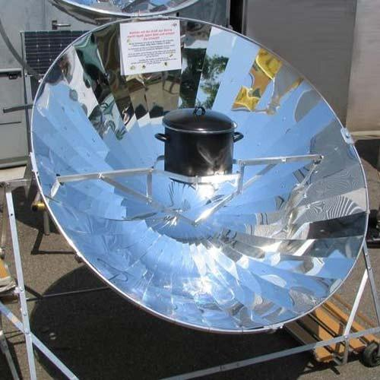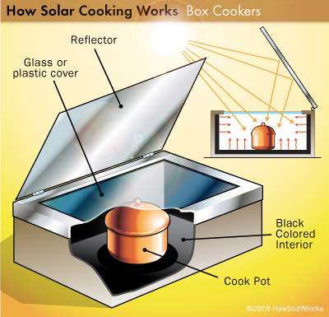
Using a compound parabolic collector to generate heat and this heat is transferred using a heat transfer fluid to a hot cooking plate. When not cooking, the system can store the heat in the storage system for use later. This system is uniquely suitable for individual households as well as institutional cooking.

- Solar Photo Voltaic – solar thermal heating systems
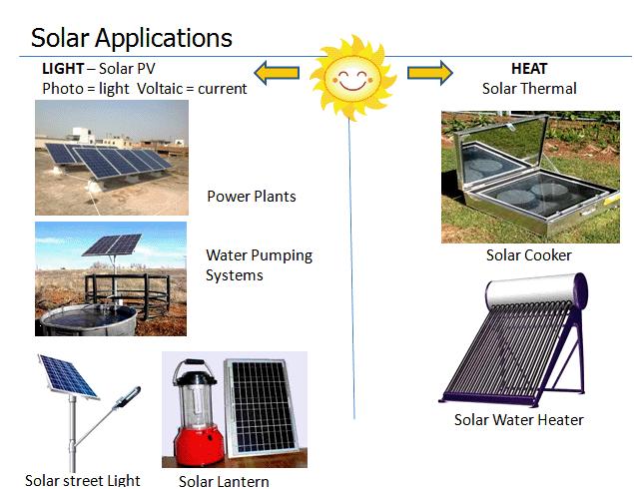

- Hybrid off/on-grid systems for household cooking

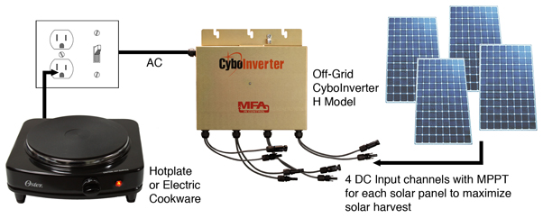

https://www.msf.org/conflict-and-covid-19-adds-crisis-libya
https://reliefweb.int/report/libya/libya-covid-19-cases-double-14-days-violence-increases-exacerbating-existing-threats
As part as the European Union (EU)-funded Action for Mental Health Assistance in Libya (AMAL) project, Handicap International conducted a qualitative survey on “Mental health-related perceptions, beliefs and practices in Libya” in Tripoli, Misrata and Benghazi. The survey took place from July to September 2019.
An example of this approach can be found in Yemen (women managed mini-solar grid project).
At present, Libya’s total primary energy consumption and installed energy capacity is 100% based on fossil fuels; however, by 2030, Libya intends to generate 22% of its electricity from renewable energy.
http://uis.unesco.org/en/country/ly
It is recommended that projects use output indicators from the Strategic Plan IRRF COVID-19 indicators, as relevant. Due to the nature of the COVID-19 response work, quarterly milestones and targets are recommended. Monitoring will be conducted using the COVID-19 Monitoring Dashboard. Reporting will be streamlined into the COVID-19 reporting exercise (mini-ROAR and COVID-19 indicators.) No separate reporting will be required for rapid financing facility.

